**Hexastela**

By Rain Cafe

Type of game:

3rd person Hack and Slash

**One Sentence pitch:**

Prove your skill in a one on one fight against a powerful monster

Hexastela is a hack and slash game, where the player takes on the role of a nameless robot on their path to defeating a strange alien creature.

The Player must dodge, dash and block the enemy’s abilities to survive the fight.

Hexastela

**Key Features:**

The main key features in our game are

True Action Combat: Characters aim their skills, instead of having a simple lock on to a target. Evading enemy attacks and aiming your own abilities becomes crucial to succeeding the fight

I frames: The Player needs I frames to evade the bosses attacks

Heal on successful block: Blocking an attack successfully heals the player. However, not all attacks can be blocked

**Our Idea:**

Interactions with the environment; The floor in which the fight is taking place is made out of two dozen connected hexagon. Each couple of hexagons share a certain glowing color, and a unique mechanism shared with their twin. They are also randomly place in each round. Both, the player and the monster has the ability to interact with the hexagons and use them to their advantage.

Monster Abilities since we’re more system design than level design?

Camera Examples

Monster Hunter

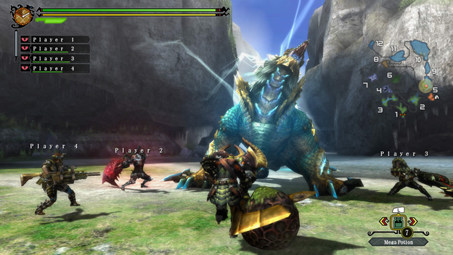

**Controls:**

We plan to use a use a controller but also allow the player to use a keyboard if they desire.

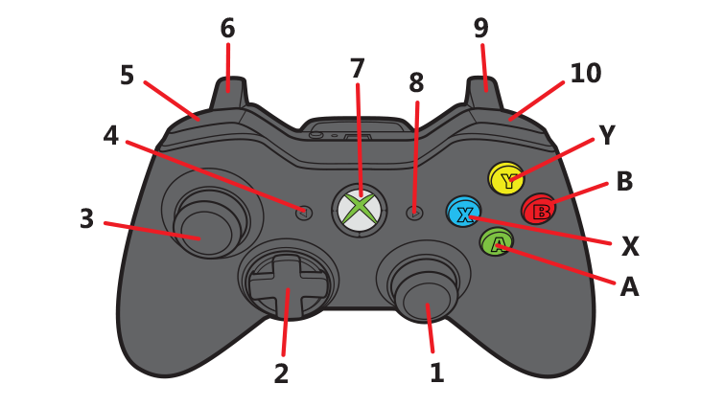**Target Market**

Monster vs Robots fans?

Monster Hunter players would probably like this

Tera players would probably like this

Furi players might like this maybe?

Competitive Analysis

Analyze Monster Hunter & Furi

**Low Art Mockup**

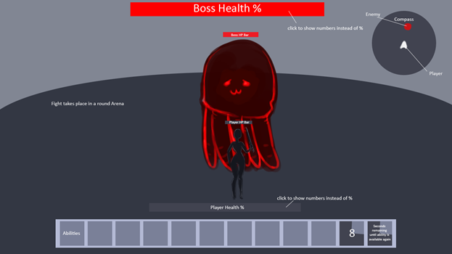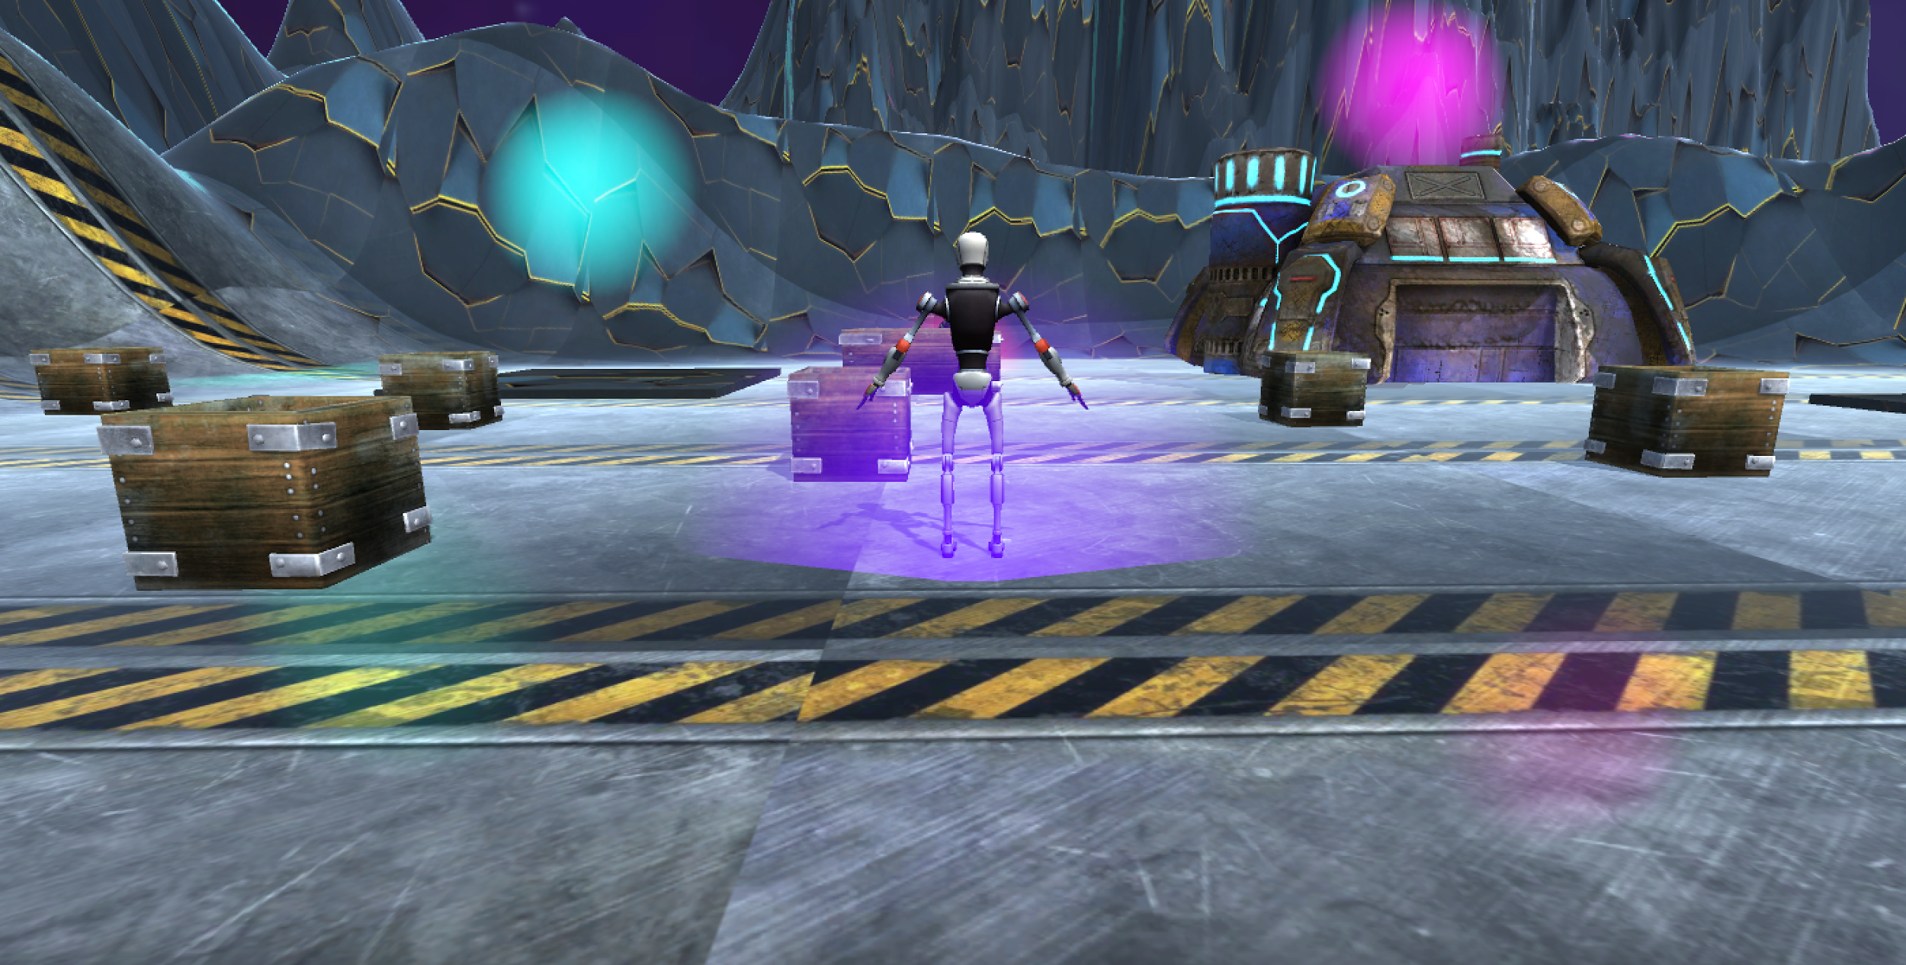 **Mockup of our game created in unity**

**Target Platforms:**

Our target platforms for Hexastela are is to deploy our project on PC and also for consoles such as Microsoft Xbox and Sony Playstation. We want to make sure our game is both playable on PC and consoles as we believe the experience can work on both platforms.

We will allow the users to play with a controller or a keyboard if they desire